PHASE 6
AI INTEGRATION & FRONTEND DEVELOPMENT

Objective:
To integrate Google Gemini AI into the AI BlogNest system and develop a simple, user-friendly frontend interface.

AI Integration:
Google Gemini AI is integrated into the backend to provide AI-based blog generation and blog summarization features.

AI Features:
- AI Blog Generation
- AI Blog Summarization
- Automatic content generation based on the user-provided topic
- Category-based blog generation
- Easy-to-read AI-generated content

AI API Endpoints:
- POST /api/ai/generate-blog – Generates a blog using AI.
- POST /api/ai/summarize – Generates a short summary of blog content.

Frontend Technologies:
- HTML
- CSS
- JavaScript

Frontend Pages:
- Registration Page
- Login Page
- AI Blog Generation Page

Frontend Activities:
- Designed user registration and login forms.
- Created a blog topic and category input form.
- Connected the frontend with backend APIs using JavaScript.
- Added loading messages while AI generates content.
- Displayed the generated blog title, category, content and author.
- Added error messages for invalid requests and authentication issues.

Expected Output:
A working frontend connected to the backend and Google Gemini AI, allowing users to generate and summarize blog content.

Phase Status:
Completed.

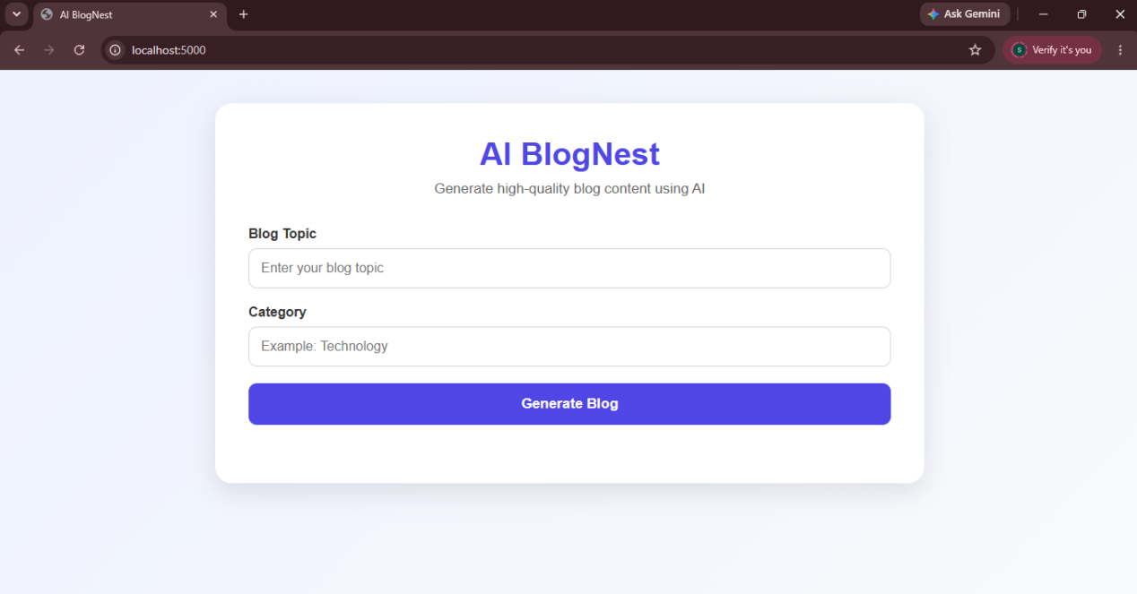
Figure 6.1: AI BlogNest Frontend Interface and AI Blog Generation

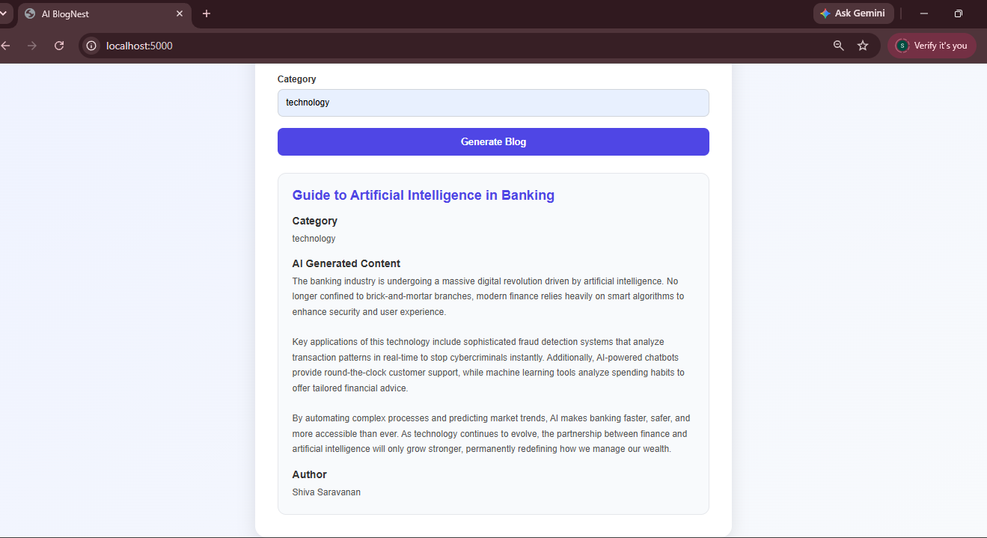
Figure 6.2: AI-Generated Blog Content

